MICRO-GROW SOG with CFLs
By

Dr. Bud Green Genes

Translated from Spanish by 9fingerleaves & alltatup

I am going to show you how to grow cannabis in a super-efficient way with the SOG (Sea of Green) technique and CFLs in a micro space.
By means of this method we will cultivate about 27 clones in a surface area of 30cm x 60cm x 70cm (12" x 24" x 28") with 210W of CFLs.
The plants will be grown in soft drink containers (600ml cut to 500ml) filled with my mixture of substrates.
These clones finish blooming in 9 weeks and will yield around 7-21gr per plant. We will harvest 3 plants per week, in the perpetual harvest mode.
The following photos are an example of what each plant will look like:
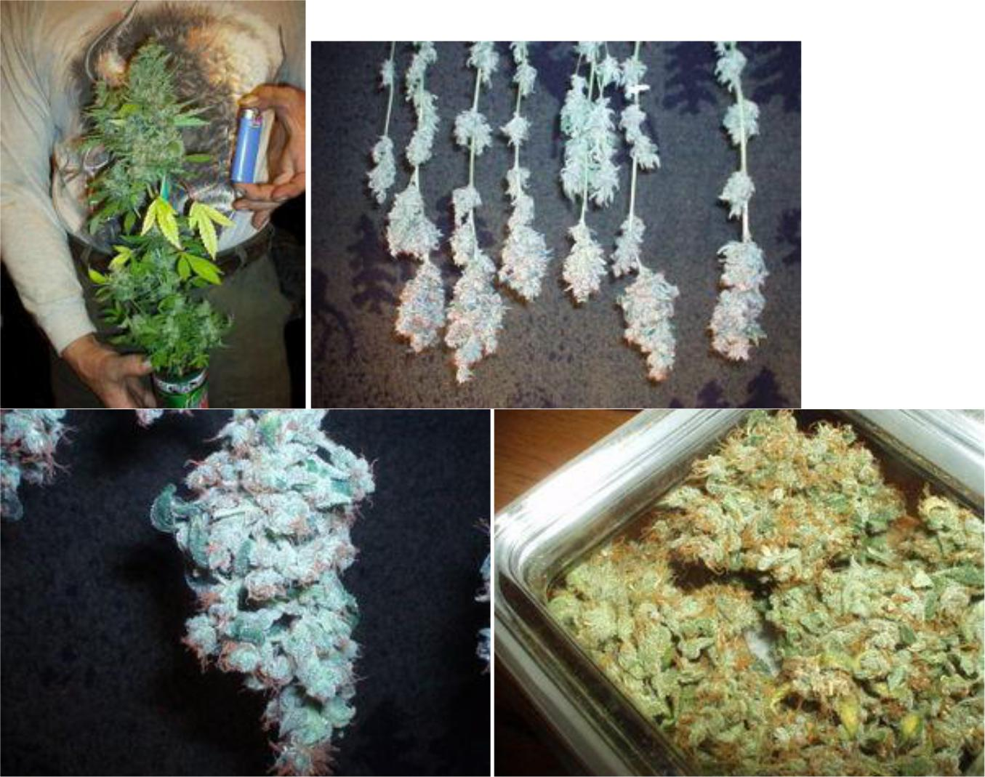

This is not a difficult technique, but plants MUST BE STAGGERED so that all plants receive the maximum amount of light possible, which would not be possible if we germinated all plants at the same time.
Staggering the plants means that plants are induced to flower at different times and thus harvested at different times. That is, 3 are harvested every week and then 3 new clones enter the grow space. The advantage of this method is that new plants may be placed closer to each other, while more advanced plants that need the most light may have much more space.
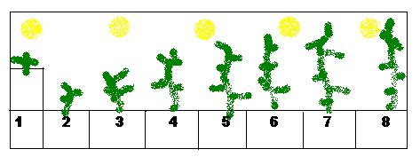

Lighting assembly:
The idea behind this is very simple. This style of cultivation requires that the the lights be mounted to a height at which the plants complete their cycle a few inches away from the lights.
Dr. Bud flowers his clones when they measure between 2-3 "; they end up at approximately 14." Based on trial and error we will find the ideal height of each strain or phenotype of cannabis.
The form we look for at the end of our plants is an elongated single cola, which is obtained by finding the "SWEET POINT" of each plant. The "SWEET POINT" (SP) is the height at which we must induce flowering to obtain the maximum height/harvest, without branching the plant. Of course the SP of each strain is different: some must begin flowering at 3 "and others at 5", 6 ", 7", etc. For example Haze x NL # 5 should be induced to flower at 1" and will be ready to harvest 17 weeks later.
Special note: During the first 7-10 days the pots should be raised approximately 6 "to bring them closer to the light, so plants will not over-stretch.

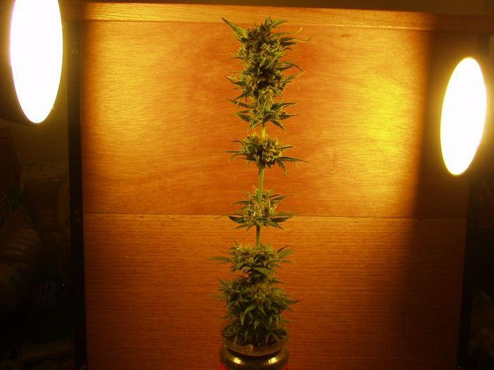

SOG (Sea of Green):
-16 plants per square foot (30x30cm)
- Plastic 20oz bottles (600ml) cut to 16oz (480ml) with 11 holes drilled in the bottom.
- In this kind of container, the light will not have a negative effect on the roots.

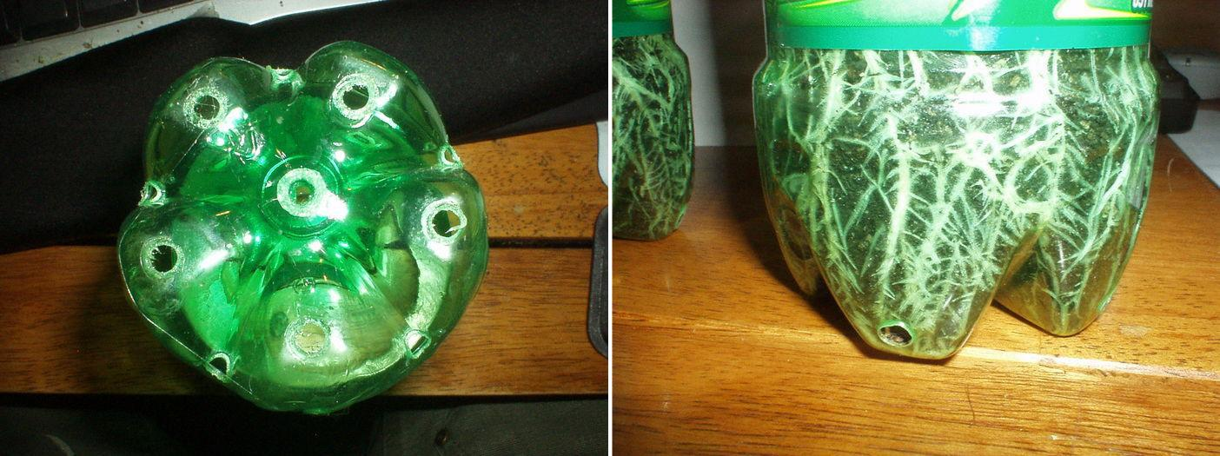

Watering:
The method of irrigation is immersion, which is only necessary in 16oz or smaller containers. The benefit of this variant of watering is that it forces the bad gases out of the earth, which ensures that the entire substrate is used by the plant.
Procedure:
1. Find a container that is slightly taller than your 16oz bottle.
2. Place the 16oz bottle into the container.
3. Fill the container with water and nutrients until the water is at the level of the substrate in the bottle. Hold the bottle down if necessary.
4. Hold the bottle down until you see no bubbles emerging (about 1-2 minutes under water).
5. Allow the bottle to drain completely before putting it back into your growing space (about 5-10 minutes).
Note: Each pot is rotated ¼ turn each time it is watered (every 3-4 days); thus all sides of the plant get equal exposure to the light.

You can make this process easier using a large container and adapt an outlet valve to drain, so you can water all your plants at once.
Some varieties may need much more water than others; know what each strain you are growing requires.

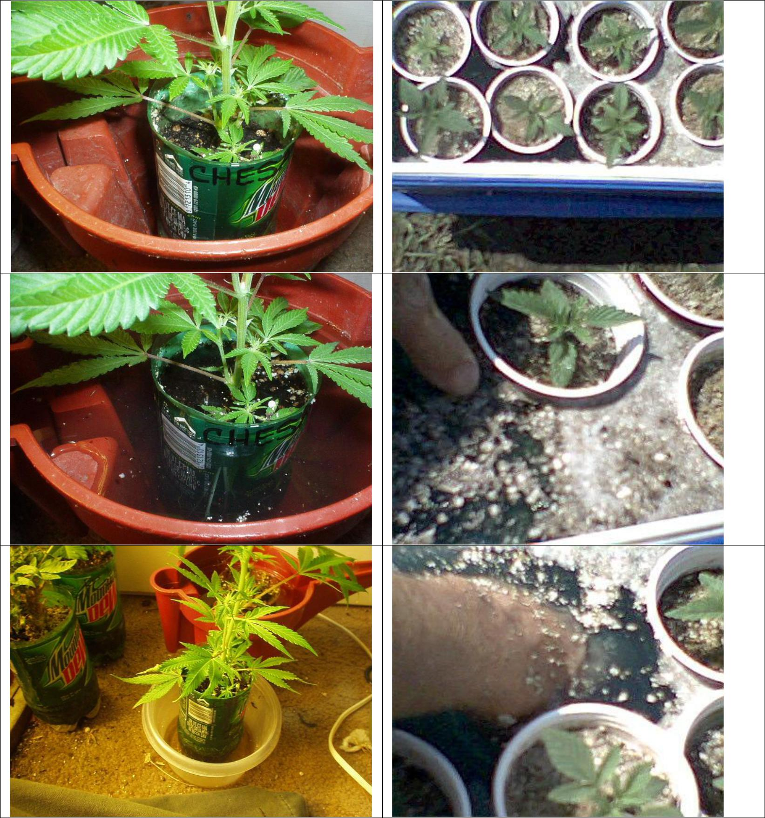

Early Sexing:
When your seed plant has reached the 3rd internode, cut it. In approximately 5-7 days, you'll have to make two 1-inch clones. Use these two to determine the sex of your plant once they have rooted. Discard male clones just like the plant you took them from, or save it in case you want to use it to make crosses later.
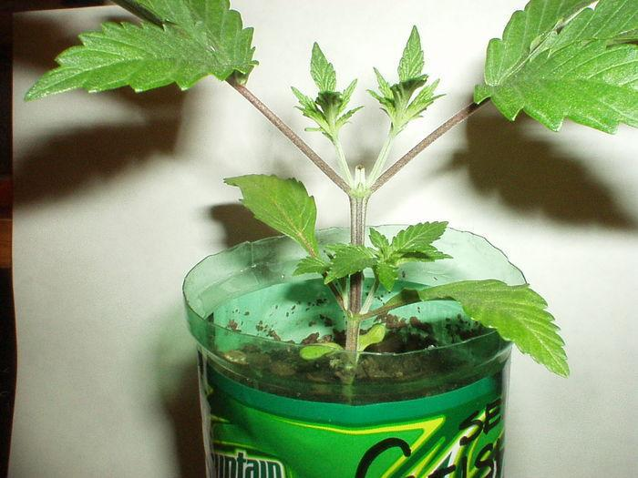

Cloning:
- Use a perlite bed in any clear or opaque container that has a lid.
- Saturate the perlite 100% with 10 drops of SuperThrive per gallon of water and remove excess water, leaving 1/2" of water under the perlite.
- Press the perlite firmly and make a small hole in it of 1-1 1/2 inch.
- Prepare your clones and put one in each hole.
- Repeat this until the container is full of clones.
- Tape the container and do not touch it for 2 days.
- After 2 days open 1 or 2 times a day for a week. Then begin to raise the lid a little each day until the container is completely open. -
- When they are ready, plant them!

To remove the clones from the tray, insert a fork under the clone and lift it gently. Put the clones in your substrate and start vegetation under continuous lighting (24 hours on), until you see some growth (usually 24-36 hours), and then switch to flowering.
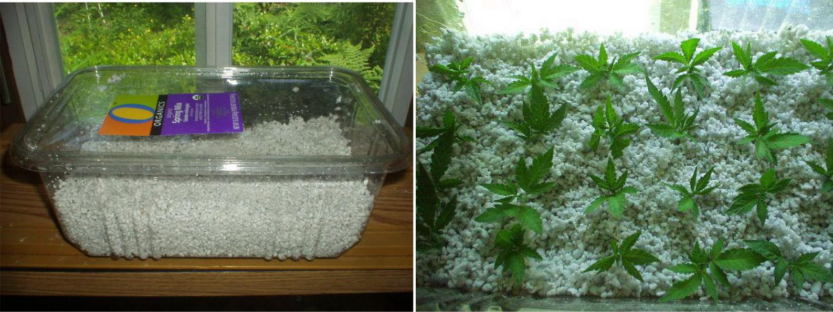

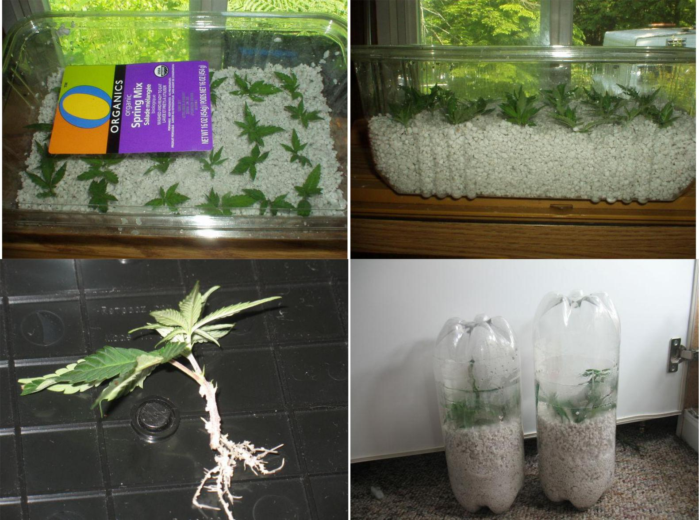

Details of the vegetative chamber:
- The clone / mother chamber measures 24" x 12" x14" (width, depth, height).
- 4 CFL's of 23W Daylight (6500 ° K)
- Extraction with 1 fan of 4 "of PC.
- The interior is painted with matt white paint.
Details of the flowering chamber:
- The flowering chamber measures 24" x 14" x 28"
- 5 CFL's 42W Warm light (2700 ° K)
- Extraction with 3-4 fans of 4 "of PC
- The interior is painted with matt white paint
Notes:
- The temperature inside the chambers should be very stable, between 22 and 24° C (72-75° F).
- 210 watts of CFL's over 27-36 clones in 2 square feet (60X30cm).
- Clones finish flowering in 9 weeks.
- Anticipate a harvest of 7-21gr. dry bud per plant.
- 3 clones are harvested per week.
- During the final 2 weeks of flowering, flush the plants in water only during each irrigation to remove excess salts.

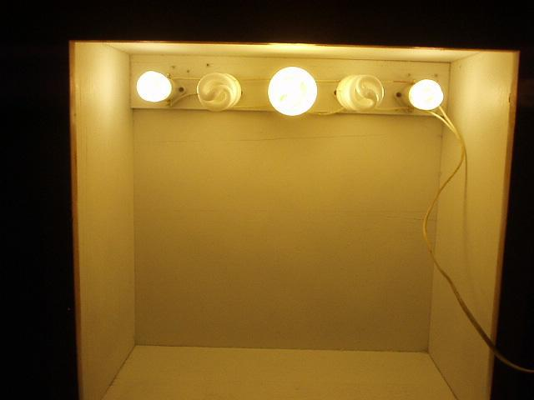

Dr. Bud's technique for making bonsai mothers
You can create mother plants who measure between 10 and 12.5cm (4-5" ) in height.
We will also create some select bonsai males for future crosses and to stabilize some varieties.
At the end of the creation of our bonsai mothers, we will be able to collect 5 to 10 clones per week from each of mother plant.
The plants will be grown in containers of 3 to 4 oz, to keep them small.
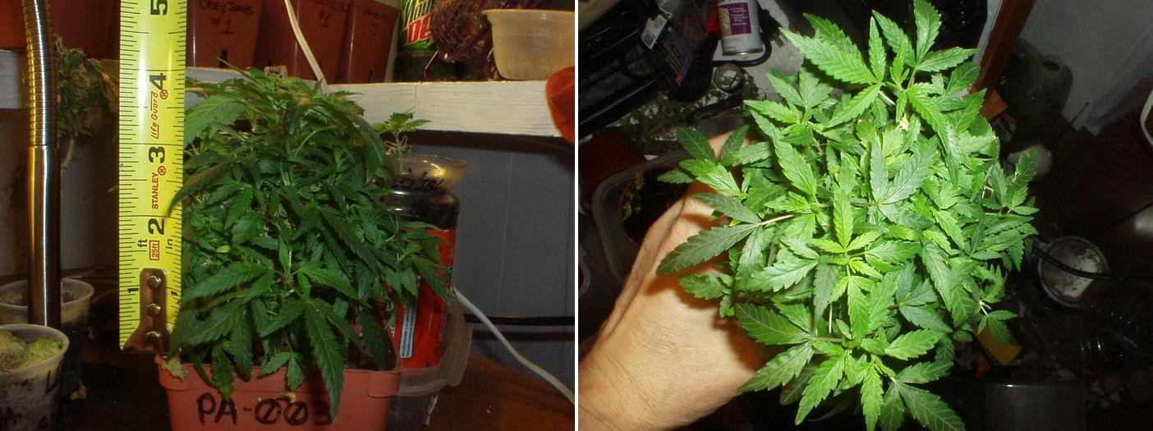

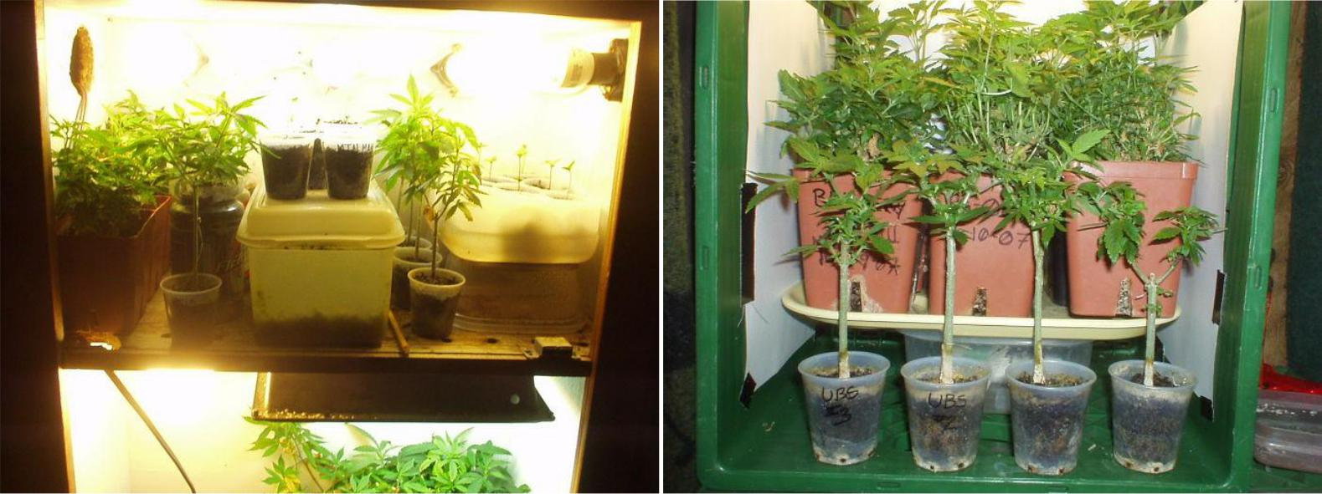

Above on the left, we have the first photo (left) of the pruning and training. In the photo on the right we see a 3" mother approach in a 90ml cup.

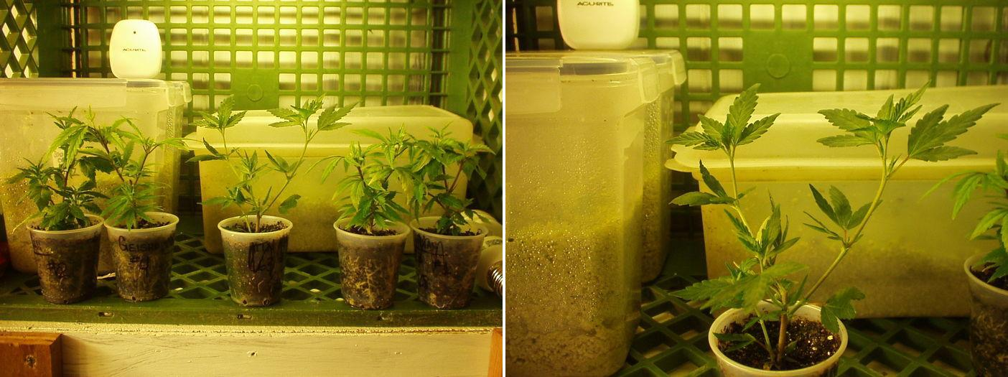

Here is the same female after being pruned (left) and to the right, the 6 small clones taken from her.
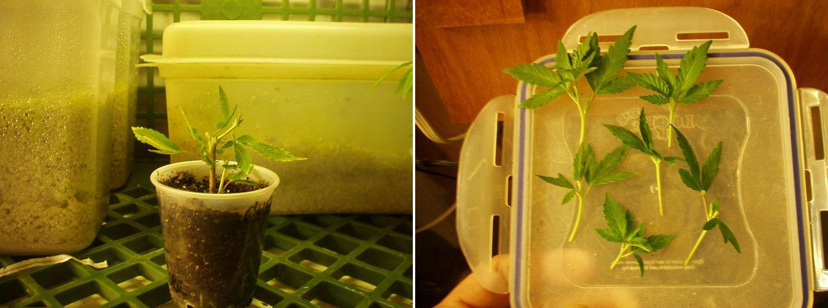

Here the same plant a week later (left). On the right, the mother after being pruned for the 2nd time.
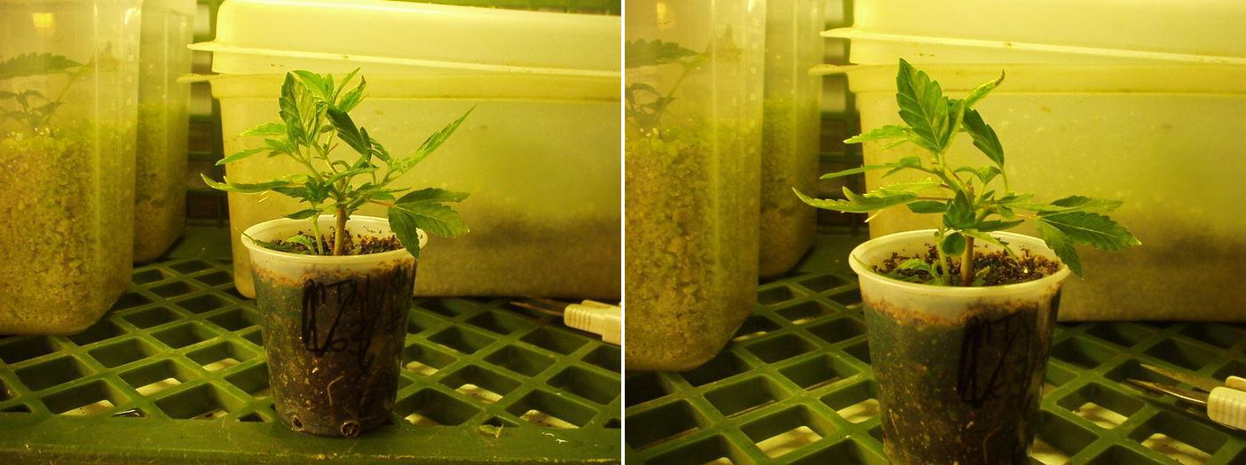

Below, the same mother plant after her second pruning/training, with more clones.
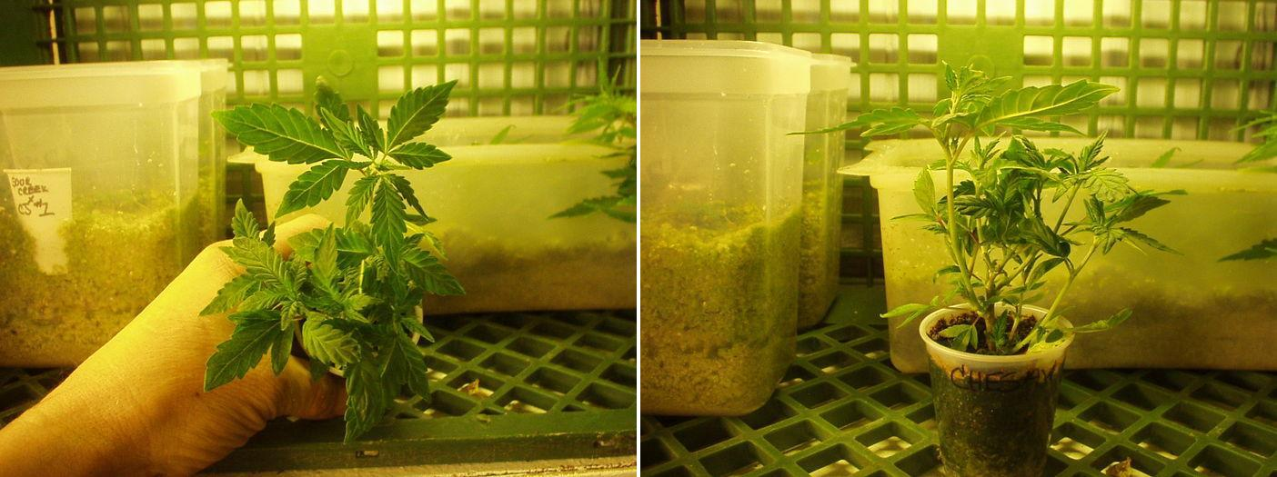

Here we have the same mother after being pruned (left). And to the right we have the 7 clones of this batch. For a total of 13 clones from a mother of 7.5cm in height....
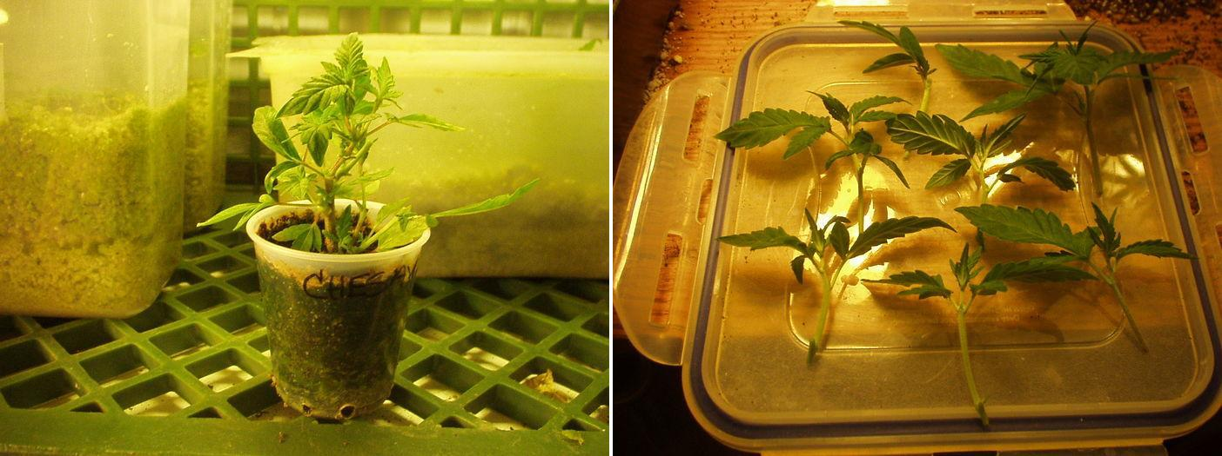

Here we have the same female before and after her third pruning.

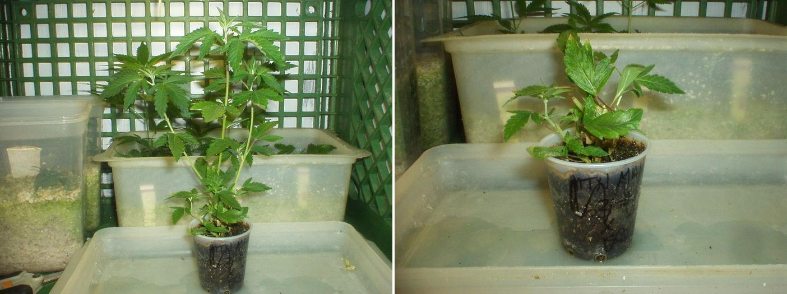

And here the 11 clones taken, for a total of 24 clones of a mother of 7.5cm high in a 90ml cup.

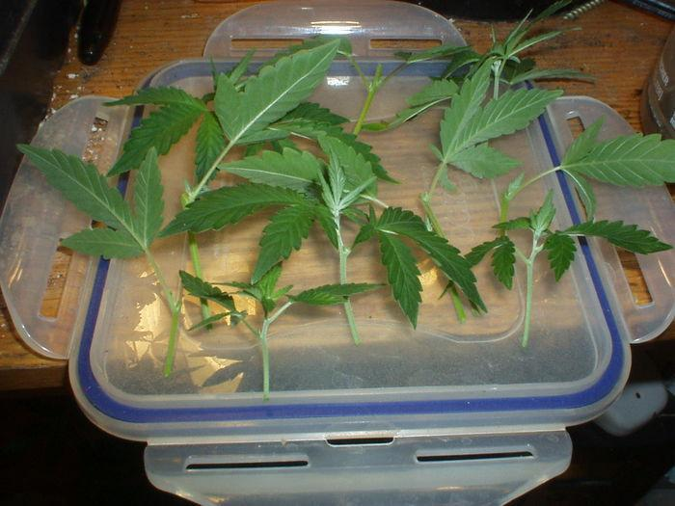

This is a male plant before and after pruning.
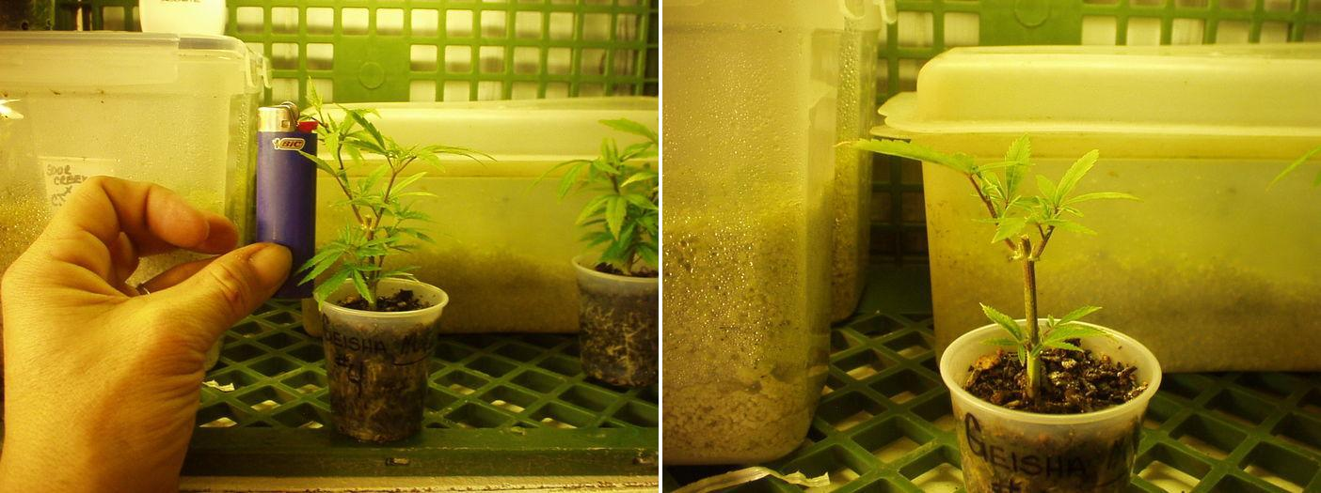
Here are the 4 male clones:

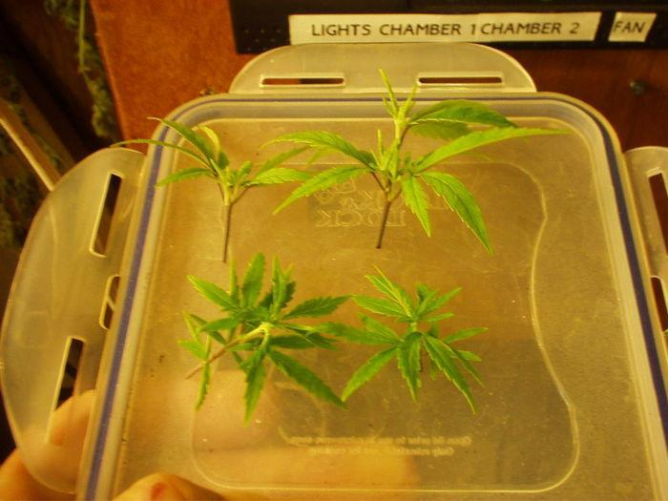

Here we see the same male a week later before and after his 2nd pruning.
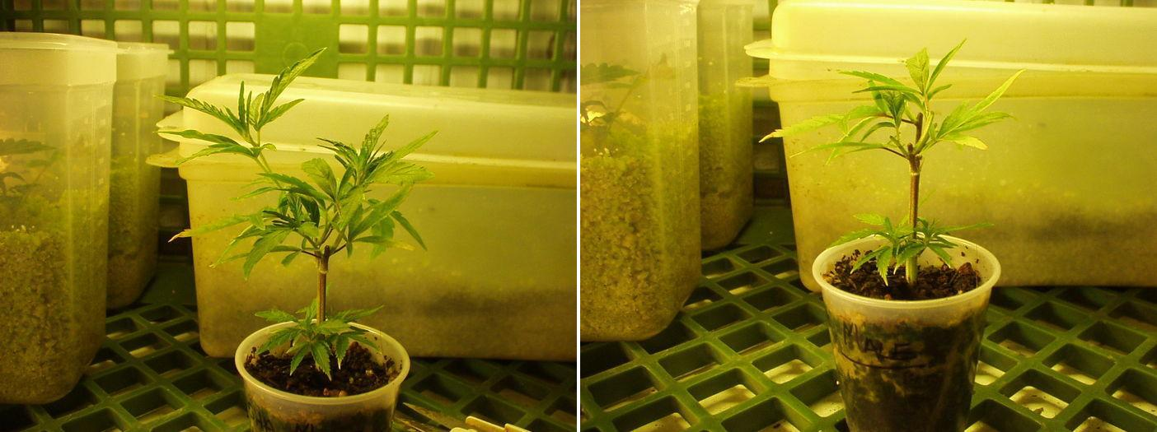

This is the same male before and after his third pruning.
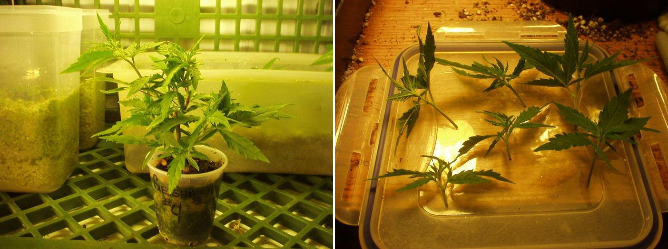

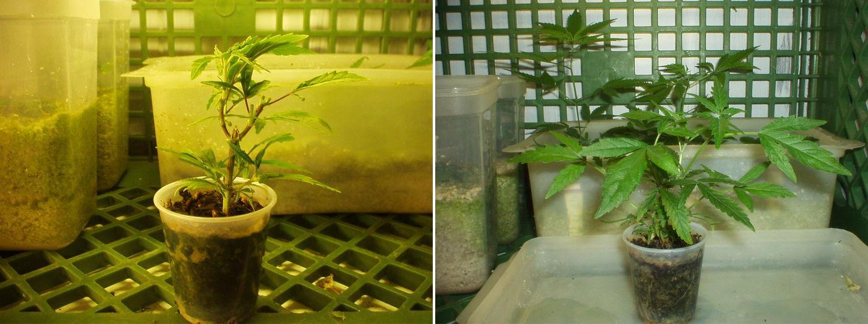
Here on the left the same male after pruning, and on the right, the same male a week later.

Below, the same male and five clones, for a total of 15 clones from a male bonsai of 7.5cm height in a 90ml cup.
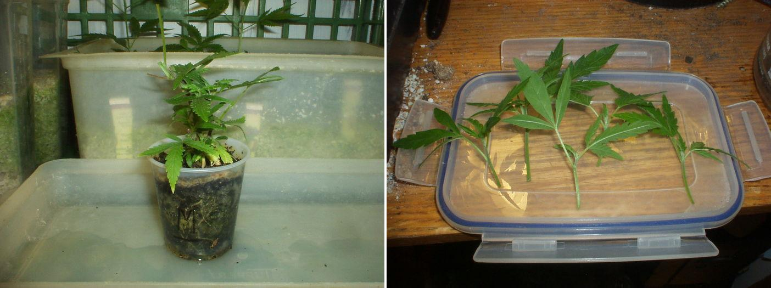
Pruning
Here we will explain the process of pruning to obtain small plants and of determining the sex early, so we will know which plants we wish to conserve.
Below on the left are the seed plants with their 3rd internode. And on the right, the same plants after pruning. Only prune the first internode, in this photo the last two internodes were cut only to demonstrate the technique, but it should not be done, only that your percentage of success in pruning is very high)

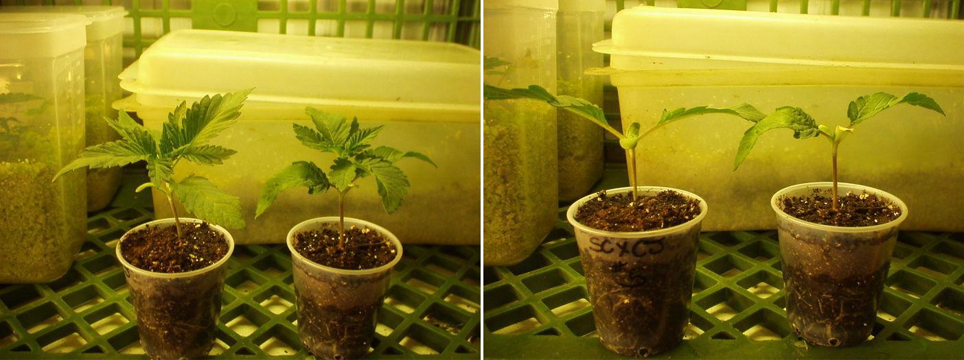

Here (left) the same plants one week later plus one plant without pruning (to the right of the photo). And to the right a view of one of the pruned plants.
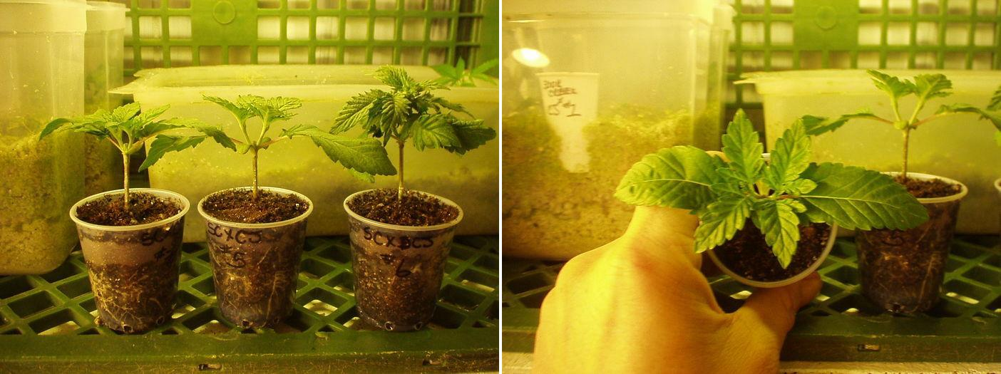

Here the second pruned plant (left). And to the right the plant without pruning.
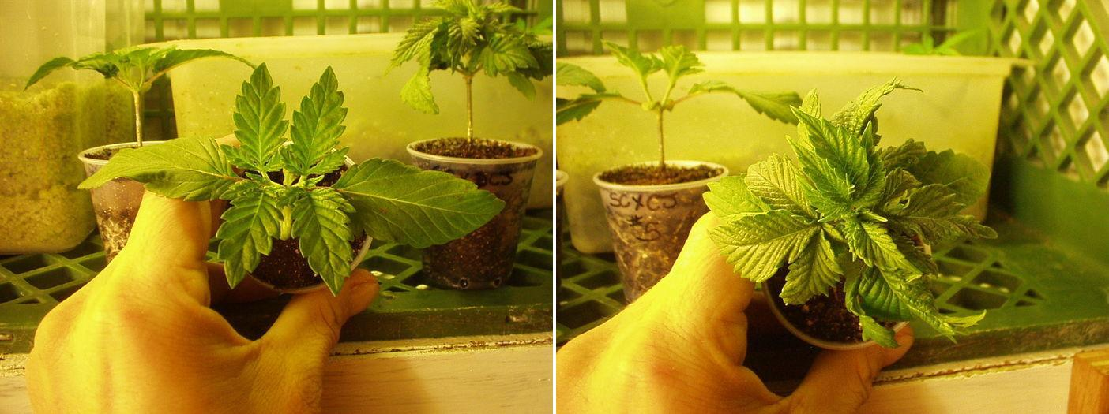

How to make a stable variety by Dr. Bud Green
Now we will learn how to stabilize a cross or variety that we have created and we like very much, in order to obtain seeds with results as predictable as possible, without unpleasant surprises.
- First of all you need a female plant which we will call Plant A.
- Then you will need a male with the best characteristics (those that look for in a plant according to your criteria) and without defects, which we will call Plant B.
- Cross plant B with plant A.
- The seeds of this crossing will be AxB 50/50.
- Plant some of the seeds, choose the best male and cross it back with plant A.
- These seeds will be ABxA and will now be 75% A and 25% B.
- Plant some seeds, select the best male and cross it again with plant A.
- Now these seeds will have 87% of the genes of plant A.
- Repeat the process again with seeds.
- The seeds from this cross will have almost 90% of the genes from plant A.
- Repeat this a few more times and you will create a stable variety.
- Your seeds will be the closest thing to your original Plant A.
Reveg Technique
The best way to reveg a plant is:
- Take a plant which you are about to harvest and cut only the largest buds of each branch. Leave the small buds on the lower branches.
- Put the plant under a 24-hour light regime and wait until the tip of each small bud begins to stretch.
- At this point, cut 90% of the small buds without damaging the new small shoots and maintain it under 24 hours of light.
- The plant will begin to absorb the rest of the buds that you left.
- From there, new branches begin to emerge from the bud sites. As soon as they measure 2", you can cut them, leaving the last 2 or 3 branches. Start new mothers from the clones to keep them small from the beginning. And the re-vegetated plant can be induced to flower again.
Note: Any plant cultivated with this method (mother or clone) can be regenerated for 3 cycles without changing the soil.
These girls are in their third re-veg:
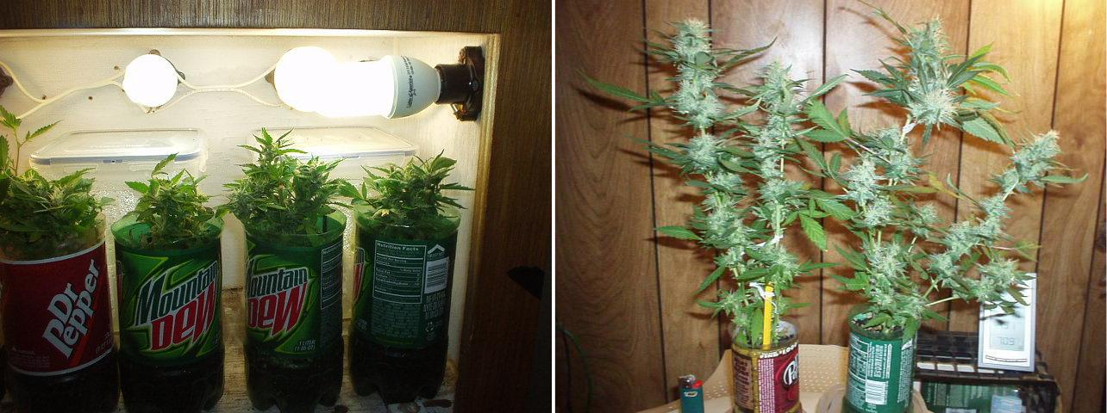
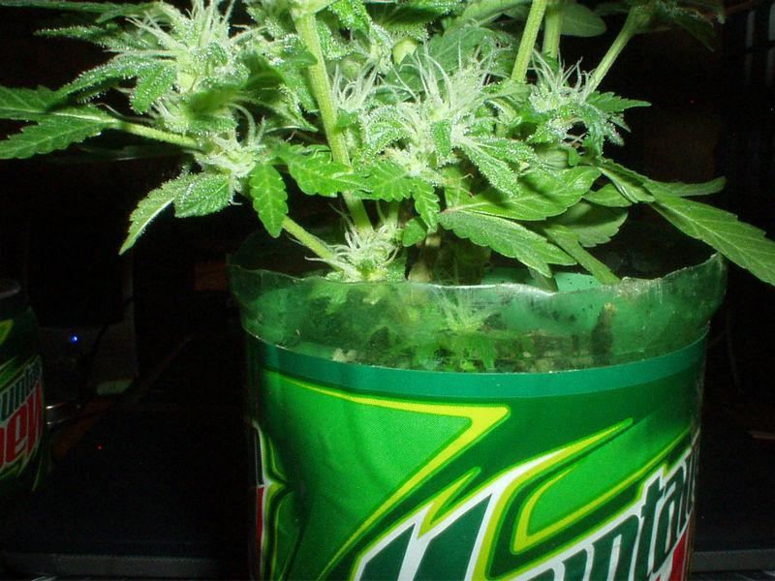

Results


